Organization Name: _____________________________________

Number of Providers at your participating organization or site(s): _________

Date: _______________________

Main Point of Contact Name (ENS Lead): _____________________________________
Phone Number: _______________________
Email: _______________________________

Introduction
Encounter Notification Service (ENS) is a system built by CRISP to notify you in real time
when one of your patients has an encounter at a hospital in Maryland or Washington DC. CRISP currently receives notifications in real time for any patient admissions, intra-facility transfers, and discharges. Using ENS, we have the ability to send notifications of these hospital events to anyone who needs to track a certain patient population. These notifications may include the hospital event type (i.e. admit, discharge, transfer), as well as additional information, such as updated patient demographics and recent prior admissions.

For a complete list of participating organizations, please visit: https://crisphealth.org/FOR-PROVIDERS/Participating-Organizations

Justification of Patient List:
Participants receiving alerts must use their judgment, based on their clinical background or other health care expertise, to provide CRISP a patient list that only includes information related to patients for whom they can reasonably expect that the majority of hospital events will be relevant to their care and/or care coordination of that patient. For example, an OBGYN provider may choose to receive alerts only for patients that are currently expectant but not for all other patients.

Please explain below your justification criteria for subscribing to encounter alerts for the patient panel that is being submitted to CRISP. For example: “These patients are an active part of my PCMH panel”, “These patients are regular patients to my practice and whom I have seen in the previous 18 months”, or “These patients are high risk patients which I must be notified immediately of their hospitalization.”

_________________________________________________________________________________________________________________________________________________________________________________________________________________________________

Hospital Affiliation
As ENS is a Maryland hospitalization alerting service, ENS is available to physicians who are members or affiliates of the medical staff of a Maryland or Washington DC hospital which participates in CRISP.
Please check if your organization has employees that are:
members of the medical staff of a Maryland or DC hospital which participates in CRISP.
Hospital name: ______________________________________
affiliated with a participating Maryland or DC hospital but not a credentialed member of the medical staff – CRISP will verify your affiliation with the hospital listed below.
Hospital name: ______________________________________
To view a current list of CRISP participants please go to https://crisphealth.org/FOR-PROVIDERS/Participating-Organizations

What is Required to Signup?
In order to sign up for ENS, your organization must first have a signed Participant Agreement with CRISP and an updated Notice of Privacy Practices. Suggested NPP language can be found here.

Main components of ENS are:
- Input of patient list that the participant would like to track.
- Definition of trigger events for alerts.
- Mechanism for receiving alerts.

Please review the options for each main component below and designate your preferences.

Input of Patient List

CRISP needs to receive an upload of all patients for whom the participant is interested in receiving alerts. Following the initial upload, changes to the patient list must be submitted to CRISP monthly. Updates can be a complete overwrite of the previous panel (Overwrite) or a panel that reflects only additions, deletions, and updates to the previous panel (Delta).

Panel Update Type
Overwrite
Delta (Panel must contain a “status” column indicating whether the record is an addition, deletion, or update)

Please indicate the method by which you will be sending your initial patient list and subsequent patient list updates (choose one):

Direct secure email (**do not sent via normal email) - recommended

SFTP (Please have a member of your IT department contact us at 877-952-7477)
CRISP can connect to my organization’s SFTP
We would like to send to a CRISP hosted SFTP

Are the MRN’s you are providing shared with a hospital system or are they unique MRN’s from your system? (for example, if you are a Hopkins affiliated practice, do you use the Hopkins MRN or do you have your own practice specific MRN?) Please note that all patients are required to have MRN or another unique identifier.

We use hospital/system MRN OR We have our own practice-specific MRN

Please identify the hospital:
____________________________

Trigger Events
Criteria that trigger alerts to be sent are configurable for each participant. Please specify your preferences below by checking off a group of events or individual events.

We would like to receive alerts when the following events occur (choose all that apply):

Admission/Registration – recommended  A01I - Inpatient Admission  A01E - Emergency Admission  A04E - Emergency Registration  A01O - Outpatient Admission  A04O - Outpatient Registration | Discharge– recommended  A03I - Inpatient Discharge  A03E - Emergency Discharge  A03O - Outpatient Discharge
Transfer– recommended  A06I –From Outpatient to Inpatient  A07O – From Inpatient to Outpatient | Cancel  A11I – Cancel Inpatient Admission  A11E – Cancel Emergency Admission  A13I – Cancel Inpatient Discharge  A13E – Cancel Emergency Discharge
CCD*
*CCD routing is only available via Direct

CRISP strongly encourages you to only select those alerts that are most relevant to your needs. Some of our earliest participants report that subscribing to all possible alerts causes more traffic than what is necessary, making the service hard to manage.

Mechanism for Receiving Alerts

Options for receiving alerts include:
- Directly into a participant’s existing electronic medical record (EMR) or other clinical system. This option will involve the participant’s technology team completing integration work to accept a message into the system. Messages can be sent to participants in HL7 format through a web services connection or via SFTP.
While this will allow a user to directly access alerts inside their Electronic Medical Record, it requires your EMR vendor to develop and implement an interface with CRISP. Your EMR vendor is likely to charge you to build this ability.
- Via a CRISP DIRECT secure messaging inbox. CRISP has a secure, encrypted messaging system that is analogous to email but can be used to exchange protected health information. CRISP can create a secure messaging email inbox for any participant, which can then be accessed via the internet or a desktop icon.
Users log into a web based e-mail program that will contain your alerts as secure e-mail messages. While this is the least time consuming, it does require you to remember a new username and password.
- Via another DIRECT secure messaging inbox. CRISP can send a secure email to any participant who is using another vendor’s DIRECT compliant secure messaging service.
If your EMR vendor supports DIRECT secure messaging protocols, please contact them and ask for their ability to support DIRECT. Your EMR vendor may charge you to implement this capability.
- Via ENS PROMPT. ENS PROMPT is a secure, web-based tool to help your organization better manage your notifications. Some of the ENS PROMPT features include:
  - ENS alerts continuously stream in real time
  - FREE to all users with no user limit on organization
  - Filter notifications by frequent ER utilizers, frequent inpatient utilizers, and TCM-eligible patients
  - Download alert data in spreadsheet format
  - Search patients by name, patient complaint, diagnosis, or organization
  - Manage notifications by status – use ENS PROMPT tracking feature to mark patients complete and help with workflow
Our organization would like to receive alerts using the following mechanism:

Directly into existing system via:
- TCP/IP over VPN
- SFTP

Via ENS PROMPT and/or CRISP Direct
If you are using PROMPT, you will still need one user with a Direct account in order to send in your panel.
Please specify your recipients:
Name | Email | Direct Email  (if applicable) | Phone | PROMPT | Direct | Direct Frequency
Real Time
Daily
Weekly
Real Time
Daily
Weekly
Real Time
Daily
Weekly
Real Time
Daily
Weekly

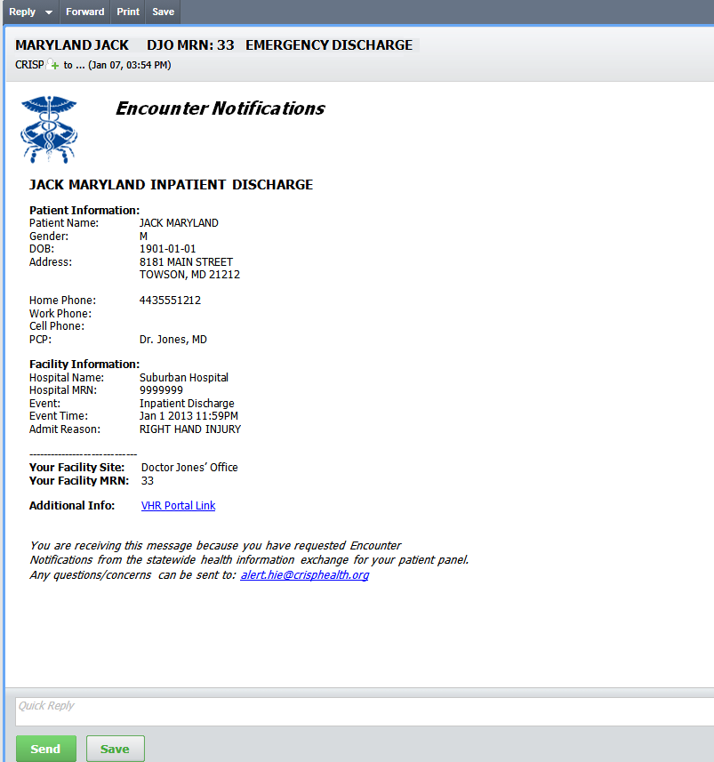
Appendix

E-mail Style Notification:

Spreadsheet Style Notification:

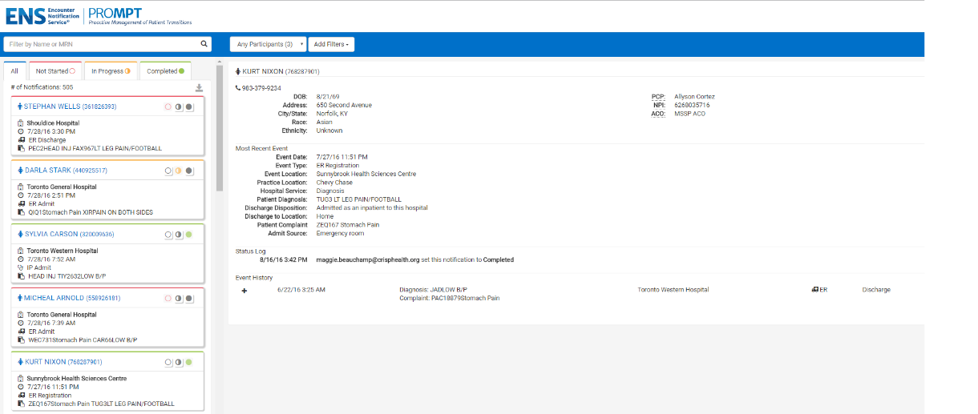
ENS PROMPT:

