Basic Care Management Software Vendor

Request for Proposal

RFP Issue Date: December 12, 2016
Proposals Due: January 9, 2017

Chesapeake Regional Information System for our Patients
7160 Columbia Gateway Drive, Suite 230
Columbia, Maryland 21046

Contents
Contents
Basic Care Management Software Vendor 1
Request for Proposal 1
Contents 2
1. Overview and Objective 3
CRISP Overview and Background 3
Care Management Software Procurement Objective 5
2. RFP Process and Submission Instructions 7
Contract Type 7
RFP Process Overview 8
i. RFP Timeline 8
ii. Bidders Conference and Requests for Clarification 8
iii. Vendor Partnerships 9
iv. Innovation 9
Terms and Conditions and Confidentiality 9
Submission Instructions 10
Proposal Evaluation 10
3. Product Proposal Content 10
A. Summary 10
B. Company Overview 10
C. Proposed Work Plan 11
D. General and Technical Questions Responses 11
4. Financial Proposal Content 11
Appendix A: General and Technical Questions 13
Appendix B: 17
17

Overview and Objective

CRISP Overview and Background

Overview
Chesapeake Regional Information System for Our Patients, Inc. (CRISP) is an independent not-for-profit membership corporation that operates a health information exchange (HIE) serving the Maryland and District of Columbia region. CRISP, a private entity chartered and governed to pursue health IT projects best pursued cooperatively, is the state designated HIE for Maryland. Its participants include each of the 48 acute general care hospitals in Maryland, all eight hospitals in the District of Columbia, as well as numerous other facilities and providers of care.

Services and Technology Background
CRISP offers a variety of services to users, all with the goal of providing real-time clinically relevant information to providers when they need it. CRISP’s core services are:
- Clinical Query Portal, include labs, radiology, and clinical documents for each patient as transmitted by hospitals and other care providers
- Prescription Drug Monitoring Program, which monitors the prescribing and dispensing of drugs that contain controlled dangerous substances (CDS)
- Encounter Notification Service, which sends ADT messages to medical personnel, providing real-time alerts when a patient has a hospital encounter
- CQM Aligned Population Health Reporting Tool (CAliPHR), which allows providers to calculate and report Clinical Quality Measures (CQMs) for federal and state incentives
- CRISP Reporting Service, providing secure access to Maryland healthcare data and related analytics tools to assist health care organizations in improving patient care throughout the state
At the center of these services is CRISP’s Master Patient Index (MPI), based on IBM’s Infosphere MDM standard product. This technology will continue to serve as the backbone of all new technology incorporated into CRISP and is what enables the management of patient identities across services. It currently houses 16 million unique identities of Maryland patients in the database. These unique identities are based on hundreds of millions of admission, discharge, transfer (HL7 ADT) messages received and processed by CRISP. In addition, CRISP receives lab results, radiology reports, electronic reports, and CCD-A, resulting in a robust set of data that gives a current view of the patient’s health status. In addition, CRISP intends to receive data from care management platforms, including care plans and program enrollment information and status. Please see Figure 1 for a diagram of CRISP’s current infrastructure.
Similar to the Master Patient Index, CRISP is in the process of procuring a Master Provider Directory, which will hold information for providers, pharmacists, care managers, and other health care professionals in Maryland. When a care manager updates a phone number, address, or other key data point in the Care Management solution, CRISP expects that the data will be sent securely to the Master Provider Directory to round out gaps in data so that others may have access to that information.

Figure 1
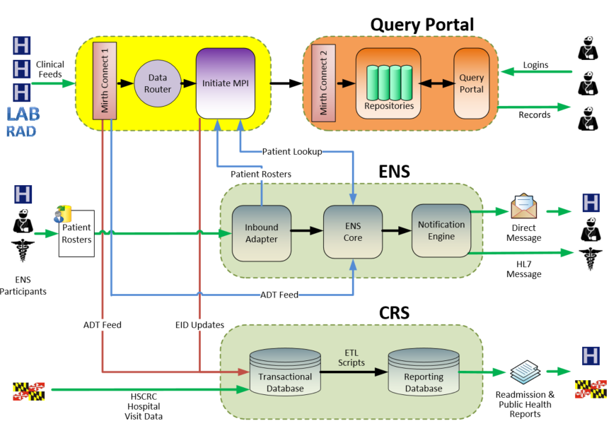

Care Management in Maryland
There is an emerging need to provide a comprehensive care management platform for use across the state of Maryland. The challenge we anticipate is managing multiple hospital-provider-program relationships and the patients they serve. With the changes in provider and hospital payments on the horizon, there is an increased need for providers and hospitals to communicate with one another regarding shared patients. This is particularly necessary when looking at Medicare reimbursement programs, such as Chronic Care Management and Transitions of Care Management, and Medicare payment models such as Merit-Based Incentive Payment System (MIPS) and Advanced Payment Models (APMs). In addition, CMS recently approved an amendment to Maryland’s All-Payer Waiver that created the Complex and Chronic Care Improvement Program (CCIP). Shared care management resources between hospitals and providers is an integral part of the program design. Central to these programs are documentation requirements and data-sharing requirements.
As the State-Designated Health Information Exchange for Maryland, CRISP is increasingly acting as a provider of state-level infrastructure to support care management initiatives that are driven by Maryland’s goals for quality and cost control as defined by the State’s All-Payer Model contract with the Centers for Medicare and Medicaid Innovation (CMMI). Detailed next steps leading toward implementation of an Integrated Care Network (ICN) infrastructure were outlined in a report issued by the Health Services Cost Review Commission (HSCRC) on accelerating strategies to meet the goals of the modernized hospital payment system. This report outlined the need for applications to make clinically relevant information available to providers and connect providers as they manage patients’ care plans. The report found that there is frequently a lack of communication, consultation, and coordination when an individual has more than one medical provider, leading to duplication of services, medication errors, poor patient satisfaction, and other undesirable outcomes. As the state HIE, CRISP is in a unique position to bring disparate health information together for use in a care management tool by disparate providers, allowing them to focus on provider patient-centered care. CRISP is issuing this RFP in order to procure a solution that will help to support this effort.

Care Management Software Procurement Objective
Ultimately, we want the care management software procured through this RFP to integrate with CRISP’s core infrastructure since data exchange will be key to the successful implementation of a care management solution. This includes: 1) CRISP sending the data contributed by its participants to the procured care management software such that it can be integrated and used within care management workflows, 2) the procured care management software sending care plan and program status information back to CRISP so it may be used by other healthcare providers with their own care management tool. Please see Figure 2 for a diagram of CRISP infrastructure’s future state.
Figure 2
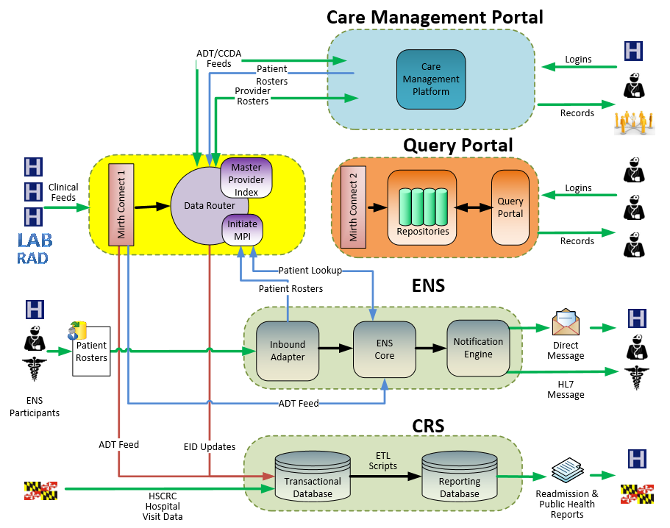

CRISP is seeking a vendor for a Care Management Software Solution that can be leveraged across the state by multiple sites. Some large health systems and ACOs in Maryland have care management systems in place already, however there are some smaller providers, ambulatory practices, and networks that need support. A CRISP-supported solution will mitigate some of the risks of poor care management by sending and receiving data from CRISP’s infrastructure to provide a complete picture of a patients’ health status and allowing for the best quality care management and care planning. The Solution will then be able to export structured care plans, allowing other providers to see patients’ goals and progress. Guiding principles of a successful solution include:
- Scalability – Ability to add new sites to the system and handle the ingestion of data routed by CRISP without an impact on performance
- Data Exchange Capabilities – Ability for data to be extracted from the solution and for the solution to ingest data sent to it by CRISP in an efficient, flexible manner, utilizing a range of data exchange approaches and standards, including using Fast Healthcare Interoperability Resources (FHIR) APIs. The solution should then be able to export structured care plans, allowing other providers to see patients’ goals and progress.
- Advanced Payment Model Support and Reporting- Ability for participants using the software to meet the requirements of advanced payment models within the industry and to report on the performance of their program by extracting key program-related information in an easy-to-access manner.
- Incremental Delivery – CRISP places high value on the ability to deliver functionality in usable increments.
To support State efforts, CRISP is seeking to procure a care management software solution that will integrate with CRISP’s core infrastructure. The system will create and maintain care plans and related clinical data. The scope of work for this project includes setting up interfaces to exchange data between CRISP and the vendor; development and deployment of training materials; and ongoing support to ensure users are optimizing the tool. The engagement will begin upon execution of a contract and is expected to continue for the duration of the contract.

Minimum Requirements
A solution CRISP procures must meet the following minimum requirements:
- Ability to automatically exchange data with the CRISP
- Functionality to create care plans
- Functionality that supports Chronic Care Management (CCM) documentation requirements for billing
- Ability to automate report creation and secure sending. User-facing report creation is a plus

Vendor Qualifications
Key qualifications for a vendor include:
- Proven success facilitating Medicare care management programs like CCM and Transitions of Care Management (TCM)
- Knowledge of state and federal Advanced Payment Models and care management initiatives
- Compliance with HIPAA and the Maryland Medical Records Act
- Knowledge of health care industry-standard protocols for data transfer and demonstrated success in using standard protocols
- Knowledge and experience working with HIEs is preferred but not required

Scope of Work
The proposed scope of work is to implement a care management software solution, integrate data systems, and deploy the solution to CRISP’s stakeholders. Major project tasks and key deliverables are described in Figure 3.
Figure 3: Tasks
Task | Timeframe | Proposed Major Deliverables
Development of Conceptual Implementation | Within 14 Days of Contract Execution | Implementation plan including timelines and key action steps
Development of Detailed Implementation Plan | March 2017 | The product should include a detailed description of the solution proposed and expected increments of delivery.
Stakeholder Engagement | Ongoing | The vendor will manage and support a robust process for communicating with stakeholders throughout the engagement. Deliverables will include meeting agendas, minutes, and timeline updates to the configuration and deployment of the care management software.
Configuration and Training | Ongoing as new sites come on board | The Vendor is expected to lead conversations regarding configuration of the tool, and train sites on configuration and use.
Post Development Support | Summer 2017 | Vendor will be expected to train and transfer knowledge of maintenance and operation items to CRISP, and remain available for support for the duration of the contract period.

2. RFP Process and Submission Instructions

Contract Type
Vendors are asked to explain their pricing models in Section 4 and are welcome to propose and justify other contract types if deemed appropriate. CRISP will issue full contract specifications as part of the final procurement process as outlined in the RFP timeline below.

RFP Process Overview
This RFP requires vendors to set forth their Care Management Solution(s) and costing information. Based on responses, CRISP will select multiple vendors for in-person/webinar interviews and solution/product demonstrations and conduct reference reviews. Following the interviews, CRISP will issue refined specifications and ask selected vendors to provide a final response and financial bids.
CRISP expects to issue the final vendor award approximately two months after issuance of this RFP.

i. RFP Timeline
Figure 4, the Procurement Timetable, represents CRISP’s best-estimated schedule for this procurement. All dates, including the contract start date are subject to change.
Figure 4: Procurement Timetable
Event | Approximate Dates | Notes
CRISP Issues RFP | December 12, 2016 | Any proposal updates will be issues on the CRISP website
Bidder’s Conference Call | December 14, 2016 | Overview of RFP and answer preliminary questions
Intent to Bid | December 19, 2019 | E-mail michelle.rubin@crisphealth.org by 5pm EST if your company plans to submit a proposal
Clarifications and Q&A | Ongoing | Ongoing, posted on CRISP website  Questions may be submitted to michelle.rubin@crisphealth.org
Vendor RFP Responses Due to CRISP | January 9, 2017 | Proposals must be emailed by 11:59 pm EST
Vendor Demonstrations | February 23-24, 2017 | Demonstrations for evaluation committee and other stakeholders
Vendor Selection and Contracting | February 2017 | CRISP will contact selected bidders to initiate contracting process
Contract Execution | March 2017 | Contract will begin upon execution

CRISP will work in good faith to provide adequate and equal opportunity for all participating vendors. However, CRISP reserves the right to adjust or modify the Procurement Timetable at any point, as deemed necessary, in the process.

ii. Bidders Conference and Requests for Clarification
CRISP will hold a bidder’s conference on December 14, 2016 at 10am EST.
In addition, CRISP will routinely answer and post to our website questions and answers related to this procurement. It is assumed that all Q&A will be finalized by December 30, 2016. Please email questions and requests for clarification to: Michelle Rubin michelle.rubin@crisphealth.org.

iii. Vendor Partnerships
CRISP welcomes proposals developed by multiple vendors in a partnership for the solution. The lead partner should submit the joint RFP response. Prior history of working with other vendors/solutions should be included in the response. Any combined responses must include a Service Level Agreement (SLA) with specific roles and responsibilities between the partners (this should be further detailed and included in Section 3C of the response).

iv. Innovation
CRISP has set forth in this RFP our planned concept for a Care Management software solution. However, we understand that through ongoing work efforts, vendors are rapidly developing innovative solutions. CRISP welcomes RFP responses that meet State objectives that rely on innovative concepts outside of our identified framework.

Terms and Conditions and Confidentiality
All responses become the property of CRISP and will not be returned to responders. Responses may be disclosed to CRISP and CRISP advisors as deemed appropriate by CRISP. CRISP will hold all responses as confidential and all pricing information will be treated confidentially.
CRISP expressly reserves the right to make any decision regarding future direction or future technology partners. This includes the right to not award a contact pursuant to this RFI/RFP process. CRISP also reserves the right to:
- Accept or reject any and all proposals or parts of proposals received in response to this RFP
- Amend or modify the RFI/RFP or cancel this request, with or without the substitution of another RFI/RFP
- Waive or modify any information, irregularity, or inconsistency in proposals received
- Request additional information from any or all respondents
- Follow up on any references provided
- Negotiate any terms of contract or costs for any proposal
- Request modification to proposals from any or all contractors during review and negotiation
- Negotiate any aspect of the proposal with any individual or firm and negotiate with multiple individuals or firms at the same time
Submission of a proposal in response to this RFP constitutes acceptance of all the conditions of this procurement process described here and elsewhere in the RFP.
A bidder receiving a positive response to their RFP proposal should be prepared to immediately begin negotiation of final terms based on the RFP and other mutually agreed-to terms and conditions. The terms described by bidder in their response may be rejected in whole or in part and/or otherwise negotiated by CRISP in the contracting process. In addition, a positive response from CRISP does not assure that a contract will be entered into; CRISP may discontinue negotiations with a bidder at any time, at our sole discretion. Until and unless a formal contract is executed by CRISP and responder, CRISP shall have no liability or other legal obligation to a responder whatsoever, relating to or arising from this RFP, the RFP process, or any decisions regarding pursuit of a formal solicitation.
In no event will CRISP be responsible for damages or other remedies, at law or in equity, arising directly or indirectly from any decisions or any actions taken or not taken in response to or as a result of this RFP or response by a vendor. All responder’s costs from response preparation, response delivery, and any negotiation will be borne by the responder.

Submission Instructions
All bidders who intend to respond must indicate that intent via e-mail to michelle.rubin@crisphealth.org by December 19, 2016 as specified on the procurement timetable of this RFP. Responses to this RFP should be submitted by January 9, 2016 no later than 11:59 pm (EST) to Michelle Rubin at michelle.rubin@crisphealth.org. CRISP reserves the right to extend the closing date by posting a notice of the extended date on its website www.crisphealth.org. Vendors should submit the proposal as a single file containing all response and supporting materials. All responses should be as succinct as possible while conveying key points and capabilities.
The maximum size for all individual files should be <15MB. Therefore, please compress screenshots or diagrams.

Proposal Evaluation
Proposals will be evaluated based on:
- A preliminary examination to determine completeness of the response
- An evaluation of the Care Management Solution, including the project management plan and team
- The solution’s ability to meet communicated requirements based on response information
- Strength of proposed work plan and ability to satisfy the deliverables and meet the timeframe
- Reference Feedback
- Review of estimated price in the financial proposal

3. Product Proposal Content
The product proposal provides CRISP with an understanding of your company, proposed team, work plan, and product. Please present these sections as A, B, C, and D as outlined below, and follow the numbering convention of the “General and Technical Questions” section. Resumes for the proposed team may be included in appendices and do not count towards page limit.

A. Summary
Provide a summary of the proposal including company overview, solution overview, proposed team and work plan. (1 – 2 pages)

B. Company Overview
In this section, provide a company overview including the proposed team, a description of similar projects, and client references. This section should describe implementations at other HIEs. This section should also describe the experience and qualifications of the individual team members to be assigned to this project. Resumes may be attached as an appendix and do not count towards the page limit. The vendor should provide 3 customers for reference (use table format in Figure 3). References should be for customers with requirements like those described in this RFP. CRISP will provide vendors notice before contacting any references. (1-2 pages)
Client Company Name & Industry | Client Contact Name | Client Phone | Client e-mail | Implementation Date | Approximate Cost of Engagement
Figure 3: Client References

C. Proposed Work Plan
In this section, the vendor must describe their proposed work plan and key steps for completing the tasks and meeting the deliverables. The work plan should include timeframes for tasks and deliverables. The work plan should demonstrate the vendor’s ability to meet the timeframes described in the RFP. (2-3 pages)

D. General and Technical Questions Responses
CRISP requests responses to all questions listed in Appendix A, and all answers should be clearly provided within the context of the proposal and/or in their own separate section. Please answer the questions in a numbered format as they are presented in Appendix A. All answers provided should be succinct to ease reviewer evaluation, while providing sufficient depth to answer each question thoroughly. Please note response page limits for each section.
CRISP will assume that any non-answer will indicate that any proposed company or technology will be unable to provide or unwilling to disclose a solution to the question, and this may negatively impact CRISP’s perception of the overall proposal. Inability to provide a response to any question will not immediately disqualify a proposal from consideration.
Please NOTE: All responses, assertions, and commitments made in this proposal will be part of the contract.

4. Financial Proposal Content
CRISP requests a pricing proposal to understand the total cost of ownership (TCO). The TCO quantifies the total cost to CRISP across three years for implementing and operating the solution.
If there are variable costs involved, such as per-member per-month fees, your proposal should include estimate for any ranges relevant to your financial model. Please limit the narrative to 3 pages. Outline your financial proposal in an Excel spreadsheet and include it as an Appendix B.
The financial proposal should estimate the following costs for the project:
- Software Costs: Please describe the dimensions of the pricing model, whether it is based on the number of members, users, sites, modules, or however pricing is scaled.
- Recurring Costs: Include any initial implementation costs, ongoing subscription, maintenance or licensing fee, any 3rd party licenses or expected system hosting fees, and any add-on and optional fees.
- Vendor Labor: Vendors should provide the hourly rates by labor category and estimate hours allocated to the project. The vendor will be able to reallocate resources among labor categories but may not exceed the Labor Project Total.
- Expenses: Vendors should estimate the total expenses associated with the project including estimated trips and travel expenses. Please note, vendors will only be reimbursed for travel expenses documented by receipts.
- CRISP resources: The vendor should describe the CRISP resources, by role, they expect to need to be successful along with the estimated time commitment for each.
Other CRISP borne costs:
If the solution requires additional systems or capabilities not included in the vendor’s proposal, those should be delineated in the final tab of the spreadsheet in any form you find suitable. For example, the vendor’s solution requires 1 SQL Server license; with the expectation that CRISP will purchase the license.

Appendix A: General and Technical Questions

General (Up to 3 pages)
- What is your company’s Dun and Bradstreet number?
- Where is your company headquartered?
- How long has your company been in business?
- How many employees work for the company? How many FTE are allocated to the specific product?
- Is the company privately held or publicly traded?
- Please note any relevant accreditations your organization has achieved.
- Please describe your work with other HIEs, if any. In your work with HIEs, like CRISP, do you rely on any partnerships, subcontracts, or other relationships? If so, please explain.
- How many sites, defined as separate organizations, even if using the same instance of the software, currently use your solution?
- Please describe your largest implementation with the following:
  - Brief narrative (1 paragraph) containing problem statement and how the system is leveraged
  - Number of covered lives
  - Number of registered users, broken out by role or title
- Do you have an implementation in Maryland? If so, please describe the implementation with the following information:
  - Brief narrative (1 paragraph) containing problem statement and how the system is leveraged
  - Number of covered lives
  - Number of registered users, broken out by role or title
  - Contact information for site

Technical and Functional Requirements
For the capabilities listed below, please assert whether the proposed technology solution can support the listed functionality in Care Management Software. Please feel free to include explanations, caveats, conditions or other information that will help qualify or explain your answers. Please also include any additional cost that may be incurred by CRISP above and beyond the proposed pricing quoted.
General and Technical Questions (Up to 5 pages)
- Please provide an architectural overview, including relevant diagrams, of the solution.
- Is your solution CMS Certified Technology? If so, describe certification and provide documentation.
- Define your site implementation process. Please provide a project plan and requirements from CRISP and sites.
- Can your solution generate and receive data using the following standards? Please provide a yes or no answer.
  - HL7 v. 2.3 or higher
    - ADT
    - ORU
    - MDM
  - C-CD-A
  - C-CDA R-2 Care Plan Templates
  - FHIR
  - PDF
  - Flat files
- Please describe your ability to consume RESTful Application Programming Interfaces (APIs) and examples thereof.
- Do you provide hosting services for your system?
  - If Yes, is the system hosted by you or in a colocation or cloud service provider?
  - If No, please provide the minimum technical specifications for CRISP to host the system.
- Can your system be run via the web in a browser?
  - If Yes, what browsers does your solution support? What are your plans for future browser support?
- Does your system require software to be installed locally and run on a client machine?
  - If yes, what Operating System does your solution support?
- Explain in detail how you recommend your system be installed set up, and configured to support CRISP and its potential customers?
- In what way(s) can a patient record be created in your software? Can you receive an ADT message to auto-create a patient record? Please describe all automated and manual processes that can create a patient record.
- How are patient identities managed? Do you have an internal unique ID assigned to the patient? Can you accept external IDs to serve as the “master” ID?
- Describe your solution’s method of managing and permitting access to various data sources dependent on multiple variables.
- Describe your solution’s ability to segment different programs/organizations on a single instance of the software.
- What configuration options are available at the client user and client administrative user level (at an organization/site only; CRISP/Vendor administrative functions is addressed in a later section.)?
- How would you enable audit and monitoring of the production landscape?
- Please describe how your solution can scale up to respond to increasing data exchange and user-based utilization
Functionality (Up to 5 pages)
- Does your solution provide the ability to track time spent managing the care of each patient that can be reported on for reimbursement purposes, for example in accordance with requirements for Chronic Care Management billing (CPT 99490)
- Does your tool include risk scoring functionality? If so, please describe the scoring methodology.
- Are care plans and other care management tools in your system informed by evidence-based guidelines? If so, please describe which tools and the body of evidence used.
- Can your solution identify gaps in care? If so, are guidelines configurable or hard-coded?
- Is there a means for patients and families to access your platform directly? If so, please provide a screenshot and narrative defining identity proofing and primary uses.
- Does your solution provide the ability to document or receive encounter data? Please describe.
- Does your solution produce patient outcome reports? If so, please describe the reports and provide examples.
- What reports are available to users? How does a user define and configure reports or queries? Describe content and unique identifiers for patients. Provide sample reports and an overview of the process to create reports with visualization.
- What reports are available to administrators? What competencies are required to create reports or queries? Please provide sample reports and an overview of the process to create reports with visualization.
Customer Support (Up to 3 pages)
- Please describe the administrative toolset. What can be done through a user interface by CRISP staff and what will require coding by the vendor?
- Please describe your training process for users.
- Please describe your training process for administrators.
- Describe your approach to customer support, including your issue escalation process and how you track and resolve problems.
- Do you have a helpdesk available, and if so, when is the helpdesk available?
- Please include a copy of your Service Level Agreement (SLA), and document different levels of support and pricing, if applicable.
Availability and Disaster Recovery (Up to 2 pages)
- Please provide your average monthly uptime percentage over the last 2 years as well as the forward-looking uptime commitment (both reflected as a percentage uptime – 99.x%).
- Please describe your scheduled system maintenance activities, their frequency, and duration of downtimes associated with them.
- What is your typical planned outage time per year (as a percentage)?
- Have you had any unplanned outages in the last year lasting more than 3 hours? If yes, please describe your longest outage in the last year.
- What is your data backup approach?
- Do you have an off-site data recovery plan?
- Do you have a system fail-over approach?
- Is source code maintained by a third-party escrow agent? Please include any fee for escrow participation.
Privacy and Security (Up to 2 pages)
- How does your solution ensure the security and confidentiality of protected health information and personal medical records?
- Would you agree to an annual audit from an industry recognized third party (for instance SSAE16)? Would there be a cost to CRISP?
- Have your applications or similar applications to the one you are proposing been subjected to penetration testing? If so, please provide those reports.
- Is data in your system encrypted at rest? What method is used to encrypt data at rest?
- Does your system include secure and encrypted methods to transmit data? What methods are used to encrypt data in transit?

Additional Information (Up to 2 pages)
If your solution has functionality or uses not specifically mentioned in the questions above, please do share that information with CRISP.

Appendix B:

http://www.hscrc.maryland.gov/care-redesign.cfm
http://www.hscrc.maryland.gov/documents/md-maphs/wg-meet/cc/Care-Coordination-Work-Group-Final-Report2015-05-06.pdf

